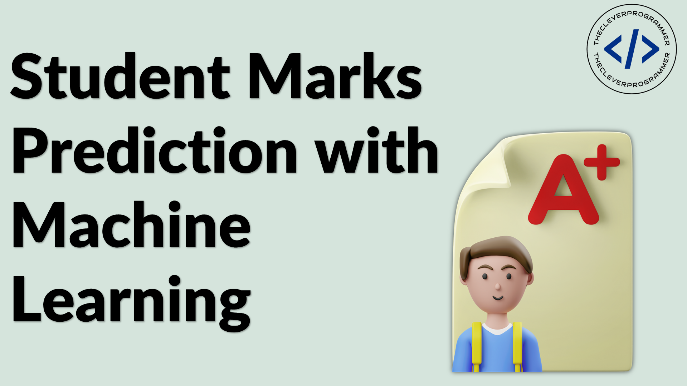

Contents:
Introduction
Existing System
Proposed System
Software Requirements
Hardware Requirements
Architectural diagram
Data flow diagram
Table Design
Data Dictionary
Relational diagram
Program design
Testing
Conclusion
References
Source code
Screen shot

Introduction:

The student mark prediction project aims to predict the marks of a student based on their study hours and percentage. The project will use machine learning to build a regression model that can predict the marks of a student with a high degree of accuracy.
Existing System:

The existing system for student mark prediction is based on manual estimation. Teachers use their experience and knowledge to estimate the marks of a student. This system is not very accurate and can lead to errors.

Proposed System:

The proposed system for student mark prediction will use machine learning to build a regression model. The regression model will be trained on a dataset of student marks and study hours. The model will then be used to predict the marks of a student.

Software Requirements:

=>8GB Ram
=>256 internal memory
=>intel processor

Hardware Requirements:

=>window os
=>Python Gui or Anaconda navigator(Anaconda jupyter or spyder)

Architectural diagram:

The architectural diagram for the student mark prediction project is shown below. The system consists of two main components: the data layer and the machine learning layer. The data layer is responsible for storing the data about students, including their study hours and marks. The machine learning layer is responsible for building and training the regression model.
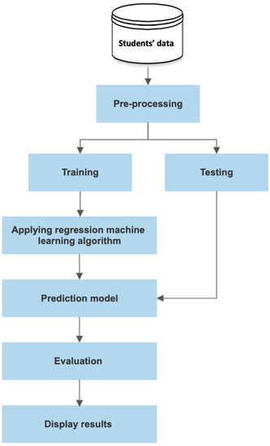
Data flow diagram:
The data flow diagram for the student mark prediction system is shown below. The data flows from the data layer to the model layer, and then to the presentation layer.

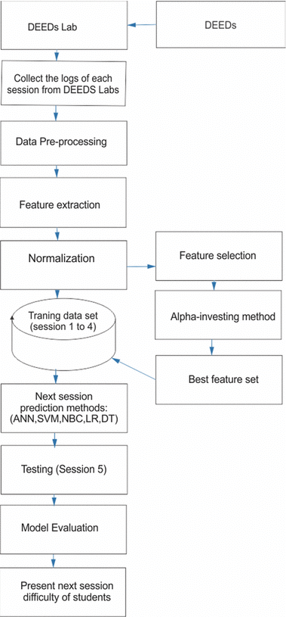
The data layer receives data from the user interface. The data is then processed by the model layer, which predicts the student's marks. The predicted marks are then displayed in the user interface.

Table Design:

The table design for the student mark prediction system is shown below. The table stores the student's name, study hours, the number of courses taken, and the student's marks.
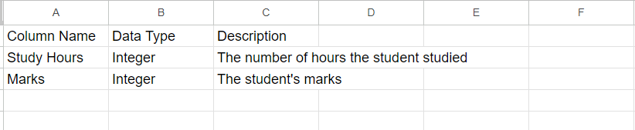

Data Dictionary:

The data dictionary for the student mark prediction system is shown below. The data dictionary provides a description of the data stored in the table.
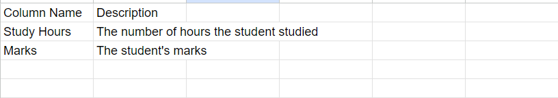

Relational diagram:

The relational diagram for the student mark prediction system is shown below. The diagram shows the relationships between the tables in the system.
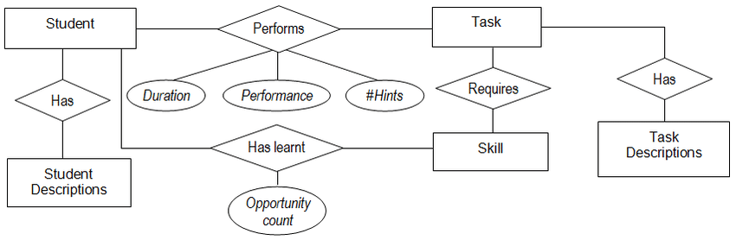
Program design:

The program design for the student mark prediction project is shown below. The program design shows the structure of the code that will be used to build and train the regression model. The program design includes the following steps:
- Import the data from the data layer.
- Clean the data.
- Build the regression model.
- Train the regression model.
- Use the regression model to predict the marks of a student.
Testing:

The testing for the student mark prediction project will be done using a holdout dataset. The holdout dataset is a set of data that is not used to train the regression model. The holdout dataset will be used to test the accuracy of the regression model.

Conclusion:

The student mark prediction project is a machine learning project that aims to predict the marks of a student based on their study hours and percentage. The project will use a regression model to predict the marks of a student. The project is still in the early stages of development, but it has the potential to be a valuable tool for teachers and students.

References:

=>From the above project we can predict the student marks based on the no.of hours they are study
=>In these project we can consider no.of.hours study and percentage we can implementing linear regression model to predict the student marks and by using flask we can create the front end to deploy
=>It is very useful for the students and teacher to predict student marks
=>After building the model we can deploy this model in server by using flask as front end

